**КЕНДЫБАЕВА ДАНА (LAB1)**

**CREATE database** lab1;  
  
**create table** users(  
 **id int not null**,  
 **firstname varchar**(50),  
 **lastname varchar**(50)  
);  
  
**alter table** users  
 **add isadmin int**;  
  
**ALTER TABLE** users **ALTER COLUMN isadmin DROP DEFAULT**;  
**ALTER TABLE** users **ALTER isadmin TYPE bool USING isadmin**::**boolean**;  
**ALTER TABLE** users **ALTER COLUMN isadmin SET DEFAULT FALSE**;  
  
**alter table** users  
**alter column isadmin set default false**;  
  
**alter table** users  
**add constraint** pk_user **primary key** (**id**);  
  
**create table** tasks(  
 **id int**,  
 **name varchar**(50),  
 **user_id int**);  
  
**drop table** tasks;  
**drop database** lab1;

Select * from users

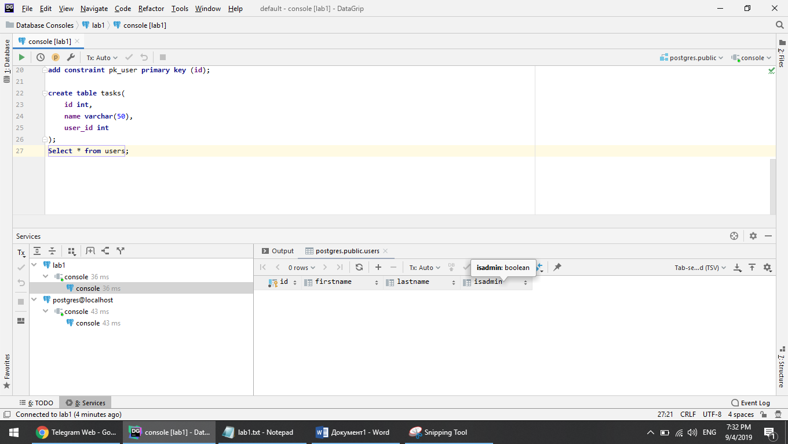

Select * from tasks

